A4 Selection Techniques Project

Objective: Practice the various techniques you learned today on selection (marquee, lasso, magic wand, and others) by combining three pictures into one.

The key is to have all three at the same resolution. All three are already set for 72 dpt. Start with the “A4 Background puppy page, then open the “Jack Russell puppies” and “Shitzu pups” images. Select each puppy separately (all four) and copy/paste into the Background puppy image. Your goal is to make the final picture believable—as though all 5 dogs were in the photo to begin with.

If you do not separate the 2 Shitzu pups and the two Jack Russell pups, you will lose points!

Print to the color Laserjet printers: 584 HP 4600.
Be sure your name and class period are printed on the photo.

Your grade will be based on the quality of your selections:

Rubric for A4:
Required | Pts. Possible | Pts. Earned
Background puppies page is set for landscape orientation | 4
Two Jack Russell Puppies are added SEPARATELY | 6
Two Shitzu Pups are added SEPARATELY | 6
Final image – quality of selections – creativity of assembling the final photo | 4
Total | 20
BONUS PTS POSSIBLE—add to your background behind the puppies with custom shapes. | 2

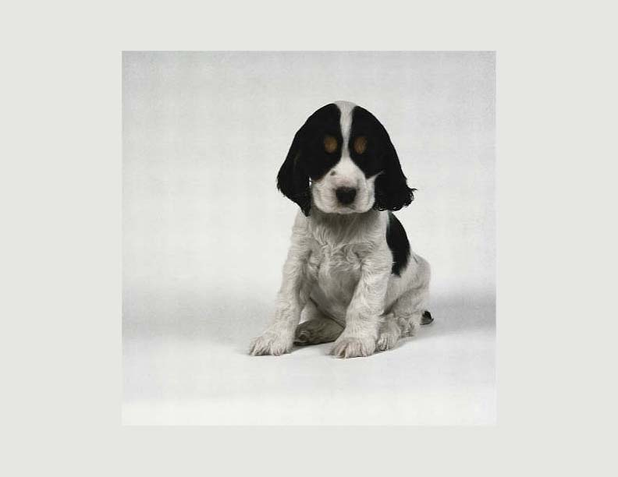
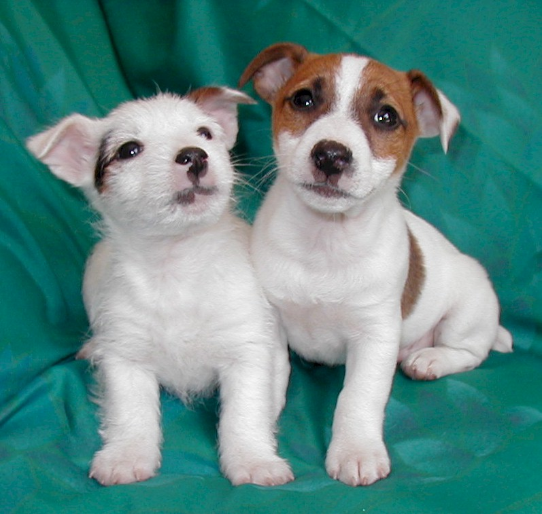
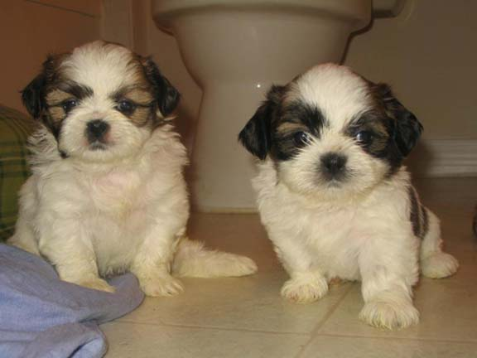
Hand in this rubric with your printed copy!.

